Task 7-1017-Vuppala Likitha

1.Install Angry IP Scanner and scan the following network blocks.

a.100.0.0.0-100.0.0.255

b.190.11.12.0-190.11.12.255

c.172.100.0.0-172.100.255.255

a.100.0.0.0-100.0.0.255

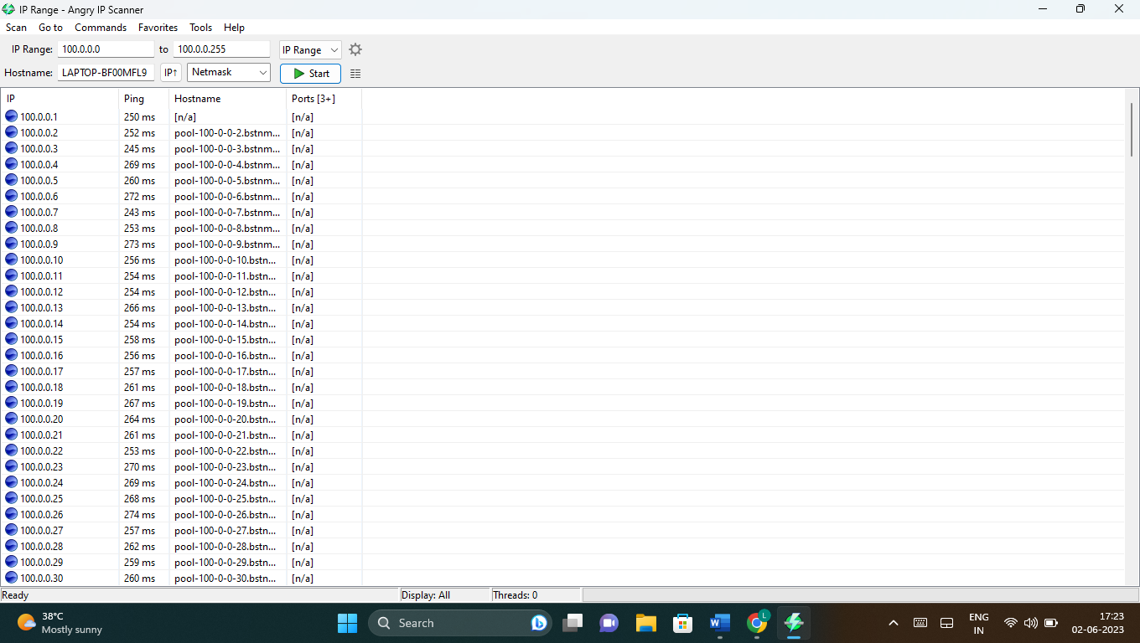

b.190.11.12.0-190.11.12.255

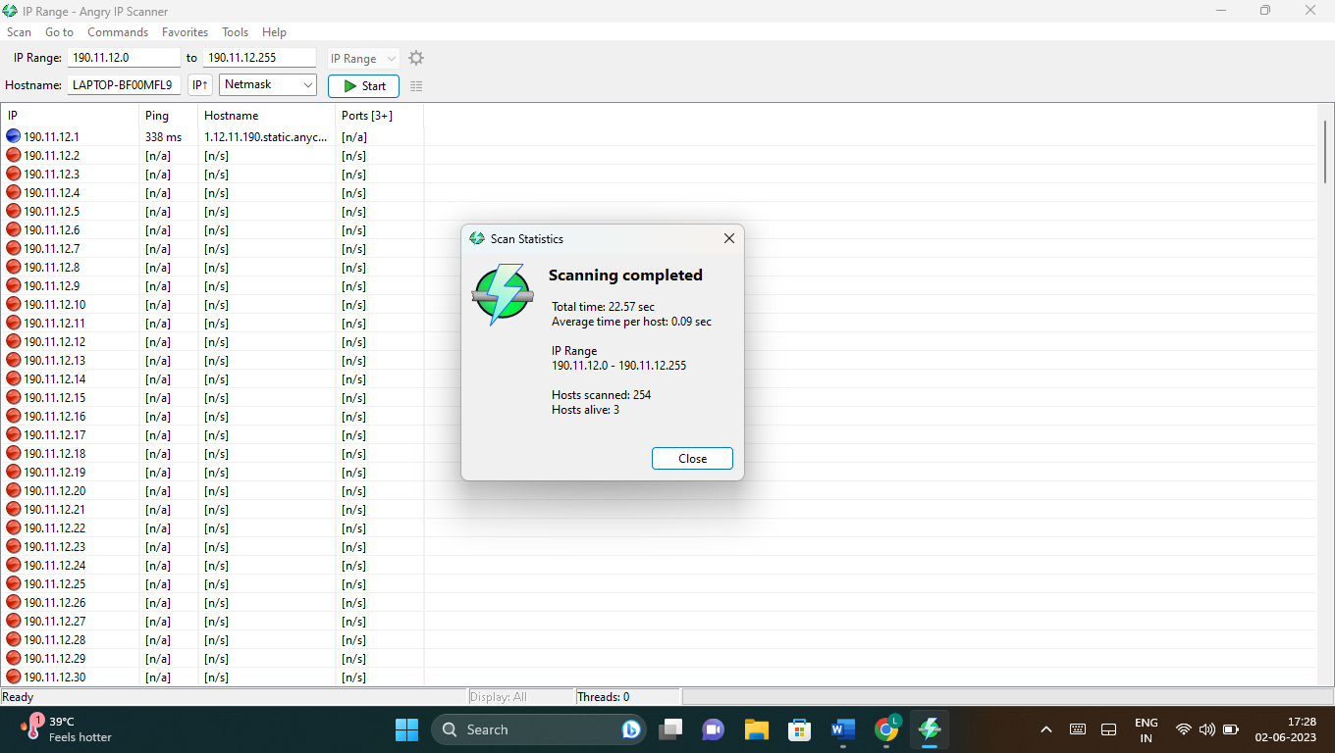

c.172.100.0.0-172.100.255.255

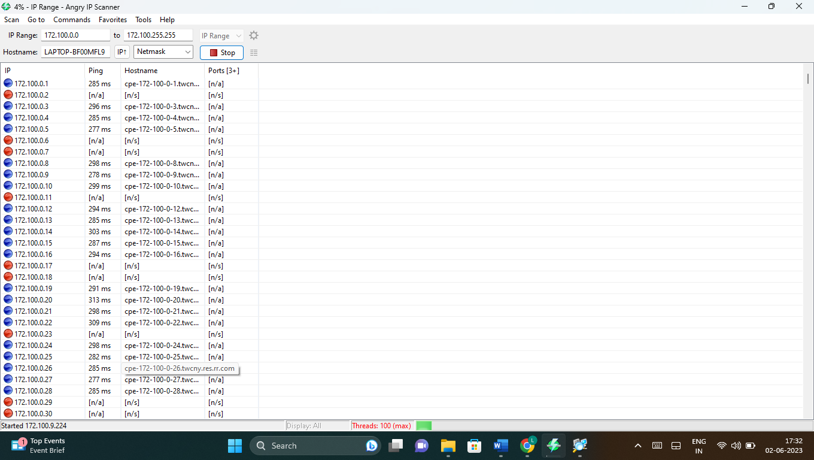

2.Install Advanced IP Sc anner,and perform the scanning. 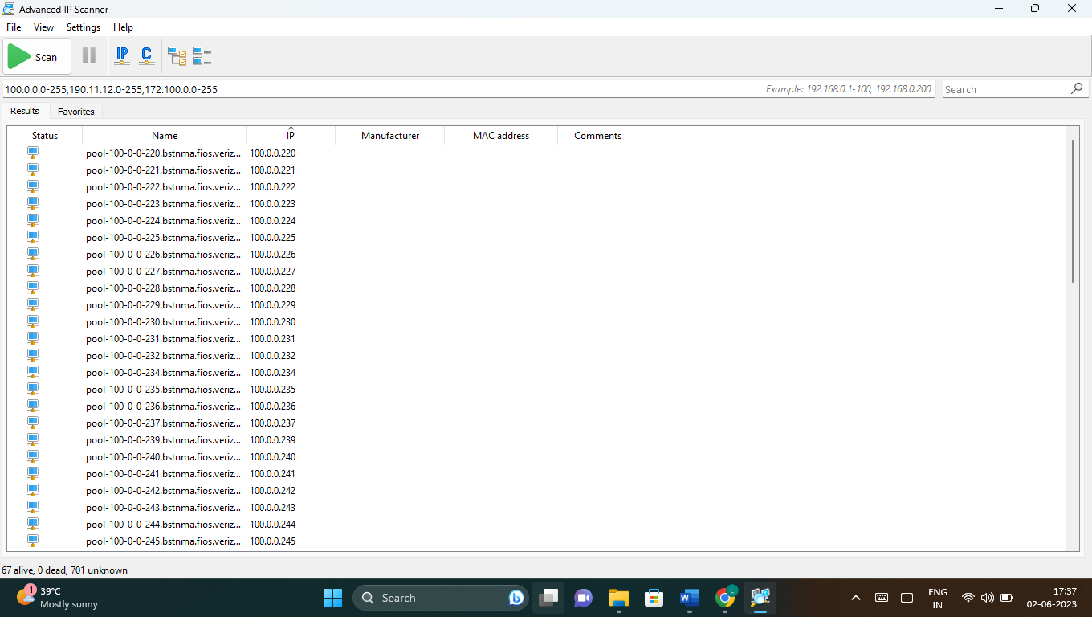

3.Download and Install WDE pro v4.2

